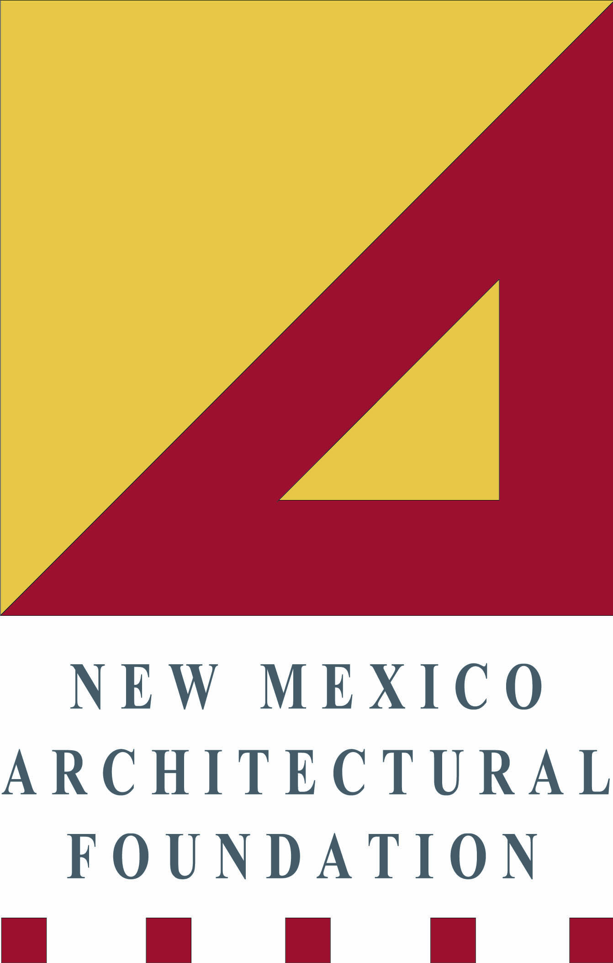

The New Mexico Architectural Foundation promotes architectural excellence in New Mexico by stimulating public understanding and appreciation of architecture and our architectural traditions.

To mark the upcoming 30th anniversary of the NMAF, we are pleased to announce an Annual Awards Program. Nominations are open and we invite NMAF members and interested parties to suggest projects and/or people to be considered for recognition. The deadline for nominations is March 31, 2017.

Nominations will be considered by a panel of AIA Fellows that we will entrust with selecting the best candidates in each category. Awards will be announced at the Foundation’s Annual Membership Meeting in May.

Three categories for recognition:

- Important historic buildings or sites that have had a lasting effect upon bringing together our community.

We are seeking projects that have brought a community together in a lasting way. Possibilities for consideration might include historic churches, public spaces, town squares, theaters, or libraries.

- Newer buildings or sites completed within the last 50 years that have made our community stronger.

We are interested in learning about projects that have been planned and designed to draw the community. Possibilities for consideration might include a community center, a public library, museum, or park.

- Devoted individuals or groups who have made a significant effort to stimulating public understanding and appreciation of architecture and in their community.

This category is for individuals or groups who are devoted to maintaining and preserving a community’s architectural traditions.

NMAF Member, John Briscoe is coordinating this program. Please submit nominations by March 31, 2017 with a maximum two-page description and at least three photos to briscoe@msn.com.

